BIN FOR RECYCLING COLLECTION

The ECO 3.0 container is characterized by a simple and linear design for optimal placement in public and private outdoor spaces (such as stations, airports, shopping centers, sports facilities, university campuses, etc.).

Its intuitive shape and graphic customization make it easy to use, encouraging correct waste separation.

The container consists of three collection compartments and a rainproof cover, entirely made of electro-galvanized steel sheet, with a triangular key lock.

The base is made of pre-compressed concrete to protect the structure from ground moisture and provide optimal stability.

The construction quality and assembly components ensure functionality and durability over time.

ECO 3.0 with lid and base
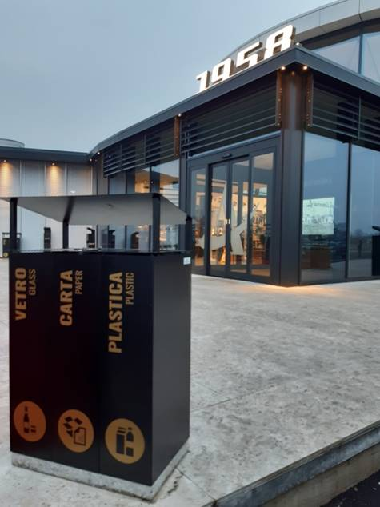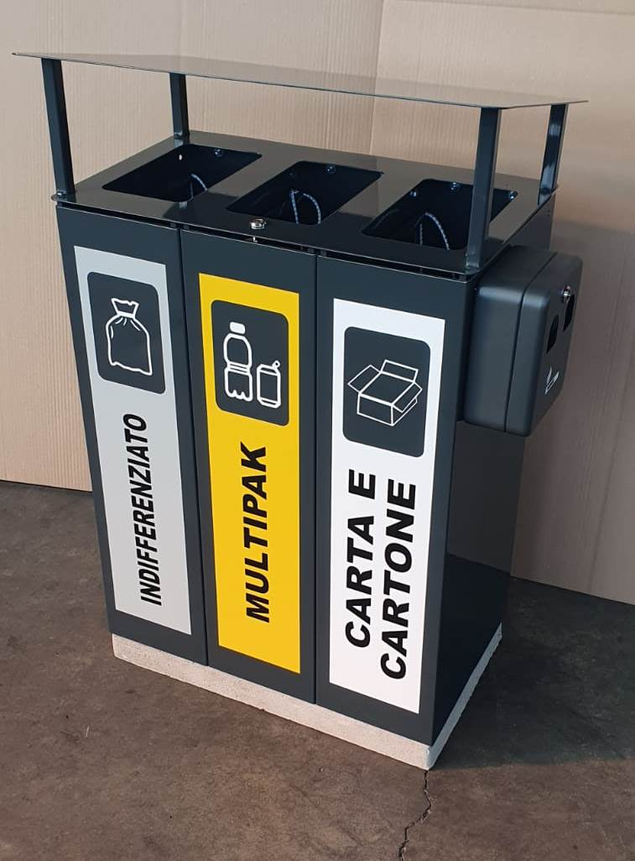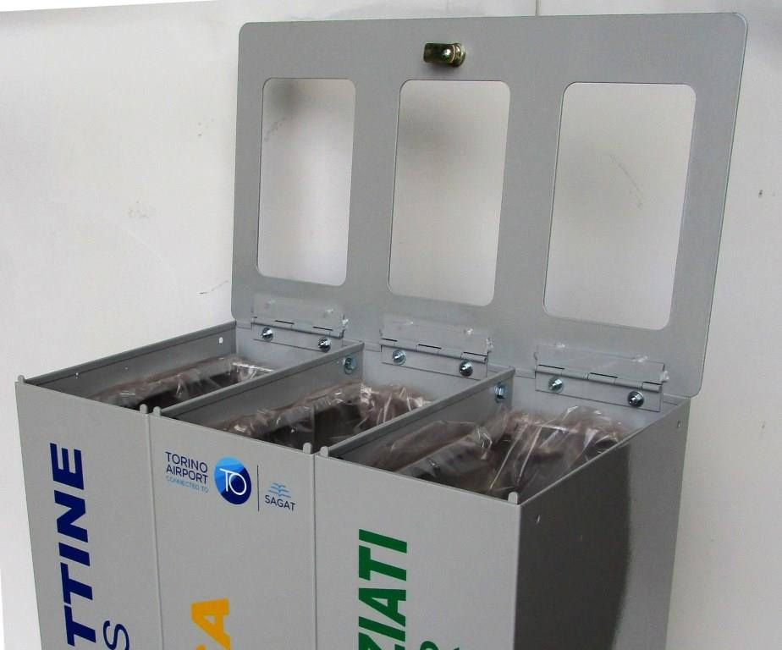

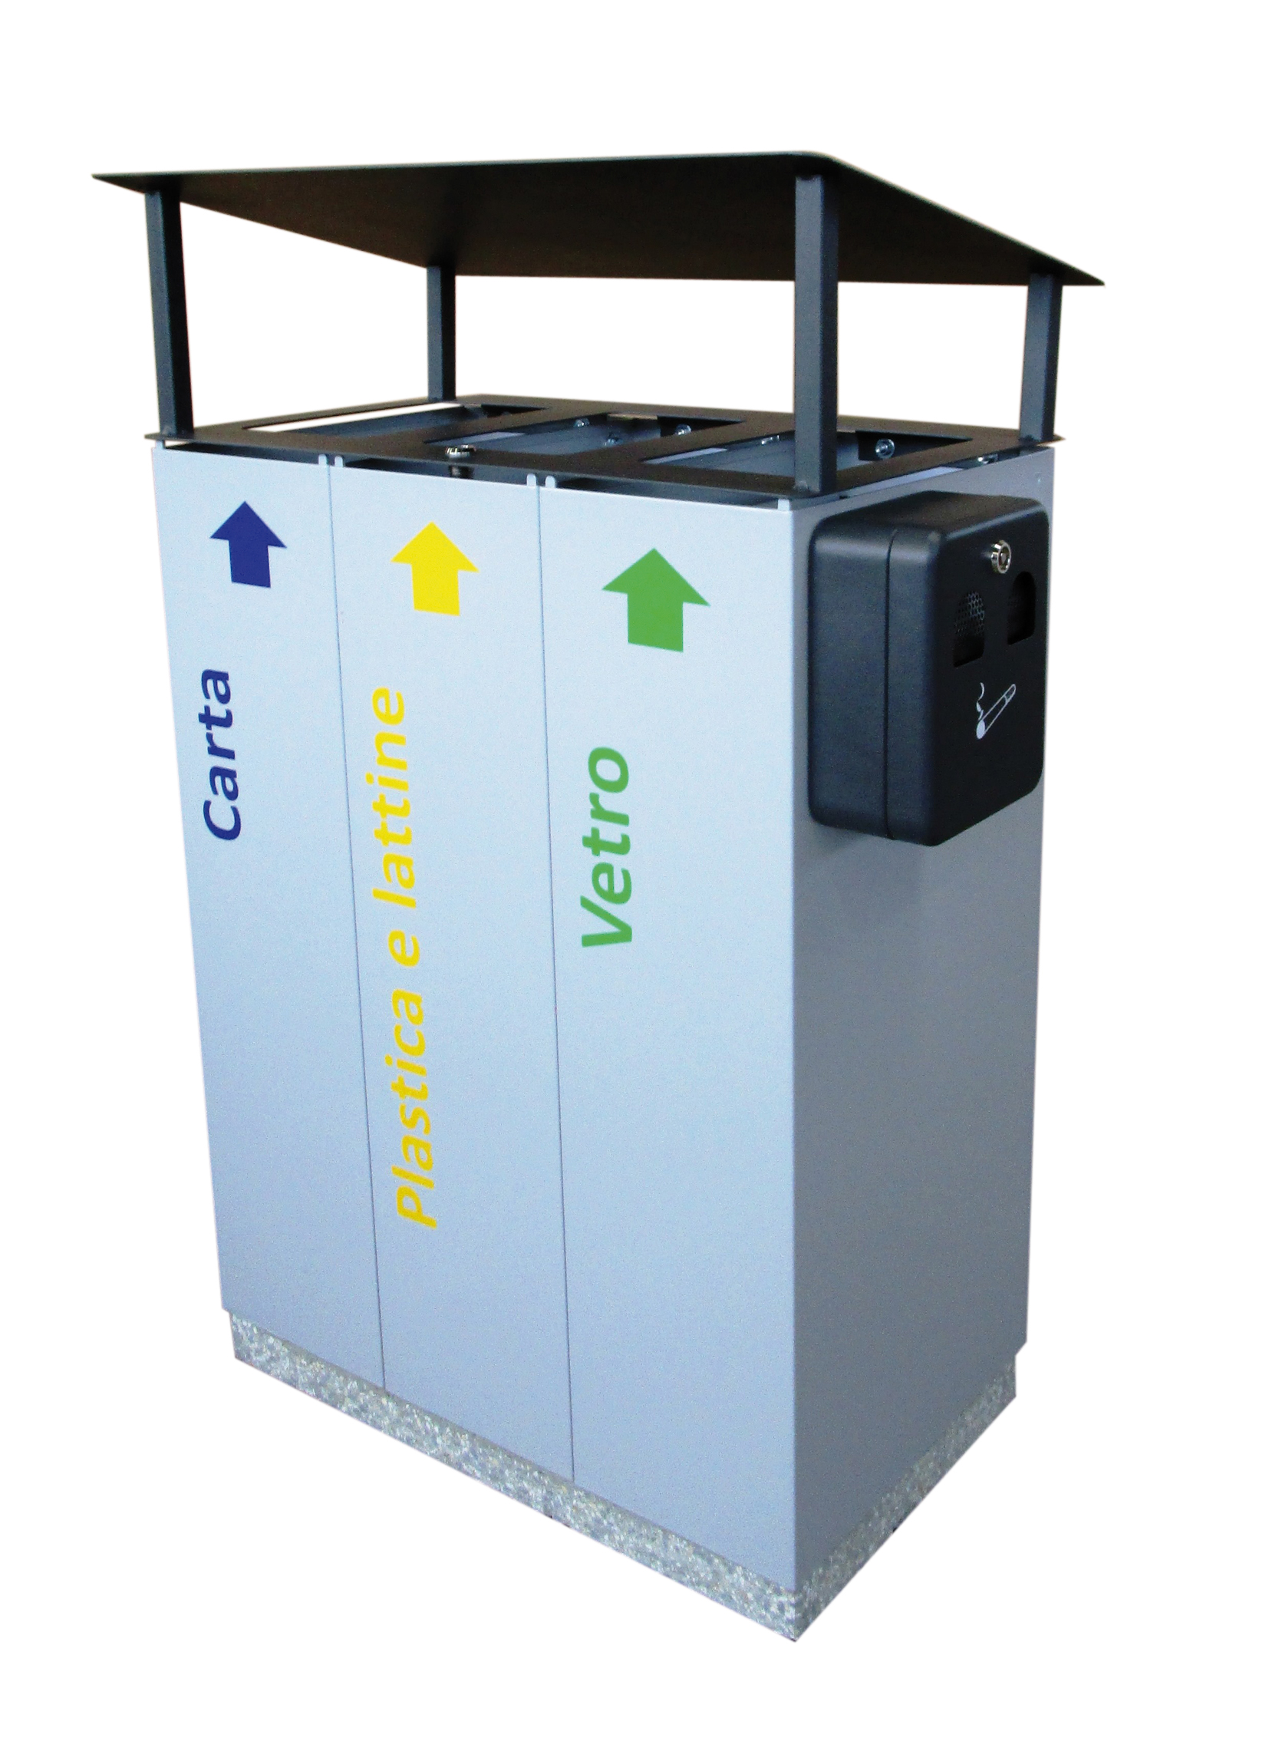
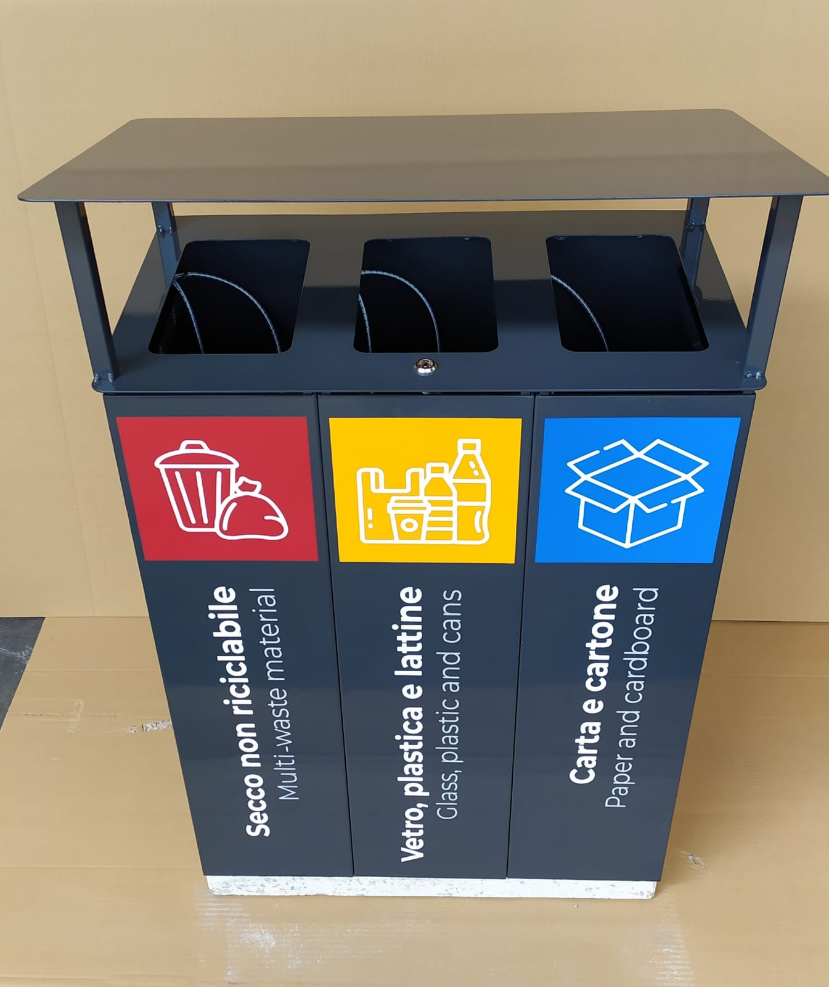
ARTICLE CODE | 1101037
DESIGN | A.U.ESSE srl
PATENT | Exclusive property of A.U.ESSE srl
DIMENSIONS | Height mm. 1020, insertion wire height mm. 820 - Length mm. 620 - Depth mm. 360
MATERIALS | Structure, panels, and bottom in electrolytically zinc-coated sheet thickness 10/10 - Cover in electrolytically zinc-coated sheet thickness 3 mm – base in pre-compressed concrete
PAINTING | Fire enamel with acid-resistant enamels - Polyester powder for outdoor use TGIC FREE QUALICOAT
NOMINAL CAPACITY | Lt. 60 x 3
WEIGHT | kg. 65
ADDITIONAL COMPONENTS AND OPTIONS | Wall ashtray
PACKAGING | Pallet with cardboard packaging
MEPA POSITION | Goods - Furnishings - Outdoor waste containers

